13/10/2025

Dear Principal,

I am writing to you today to ask for your support for young people from your school to participate in their local Comhairle na nÓg (local youth councils) Annual Youth Conference, to be held this year on 18/11/2025. The Annual Youth Conference is a space for Comhairle members to showcase their work in the previous year to their peers and encourage new people to become members of Comhairle na nÓg. This will ensure that Comhairle na nÓg can continue to grow and give a voice to children and young people in local and national services and policies.

You may be aware that Comhairle na nÓg was established as the permanent structure representing young voices in decision-making at local and national level in Ireland. Since 2002, Comhairle na nÓg have been giving young people a voice on the development of local policies and services in each of the 31 Local Authorities. Young people aged 12-17 become members of their local Comhairle na nÓg through their schools, youth organisations and community groups. Comhairle is evidence of Ireland’s commitment to the implementation of Article 12 of the United Nations Convention on the Rights of the Child, which outline the right of children to have a say in issues that concern them.

The school system is the basis for accessing and working with young people for Comhairle na nÓg, and your annual facilitation of the work is greatly appreciated.

Thank you for your continued support and I wish you all the best for the school year ahead.

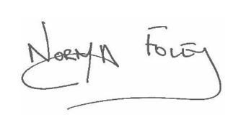
Yours sincerely,

______________________
Norma Foley TD,
Minister for Children, Disability and Equality

